## 3D BODY MEASUREMENT SYSTEM USING DEEP LEARNING WITH PYTHON

*A major project report submitted to*

## Rajiv Gandhi University of Knowledge Technologies SRIKAKULAM

#### In partial fulfillment of the requirements for the

**Award of the degree of**

**BACHELOR OF TECHNOLOGY IN**

## COMPUTER SCIENCE AND ENGINEERING

##### Submitted by

**Chandra Bharghavi - (S170078)**

**Malik Bijetha - (s170366)**

**Shaik Haseena - (s170653)**

**Under the Esteemed Guidance of**

## Mr.T.Anil Kumar, MTech

## Assistant Professor

## of

## Computer Science and Engineering department



**Rajiv Gandhi University of Knowledge Technologies - SRIKAKULAM**

**CERTIFICATE**

This is to certify that the thesis work titled **“3D BODY MEASUREMENT SYSTEM USING DEEP LEARNING WITH PYTHON”** was successfully completed by **CH.BHARGHAVI (S170078), M.BIJETHA (S170366), SK.HASEENA** **(S170653) .**In partial fulfillment of the requirements for the Major Project in Computer Science and Engineering of **Rajiv Gandhi University of Knowledge Technologies** under my guidance and output of the work carried out is satisfactory.

**Mr.T.Anil Kumar, MTech Mr.CH.SATISH KUMAR**

**Project Guide Project Coordinator**

## DECLARATION

We declared that this thesis work titled **“3D BODY MEASUREMENT SYSTEM USING DEEP LEARNING WITH PYTHON”** is carried out by us during the year 2022-23 in partial fulfillment of the requirements for the Major Project in **Computer Science and Engineering.**

We further declare that this dissertation has not been submitted elsewhere for any Degree. The matter embodied in this dissertation report has not been submitted elsewhere for any other degree. Furthermore, the technical details furnished in various chapters of this thesis are purely relevant to the above Project and there is no deviation from the theoretical point of view for design, development and implementation.

**CH.BHARGHAVI - (S170078)**

**M.BIJETHA - (S170366)**

**SK.HASEENA - (S170653)**

## ACKNOWLEDGEMENT

We would like to articulate our profound gratitude and indebtedness to our project guide **Mr.T.Anil Kumar,** Assistant Professor who has always been a constant motivation and guiding factor throughout the project time. It has been a great pleasure for us to get an opportunity to work under his guidance and complete the thesis work successfully.

We wish to extend our sincere thanks to **Ms.M.Roopa,** Head of the Computer Science and Engineering Department, for her constant encouragement throughout the project.

We are also grateful to other members of the department without their support our work would have been carried out so successfully.

We thank one and all who have rendered help to us directly or indirectly in the completion of our thesis work.

Project Associate

**CH.BHARGHAVI - (S170078)**

**M.BIJETHA - (S170366)**

**SK.HASEENA-(S170653)**

## ABSTRACT

Nowadays people are taking their body measurements by approaching a tailor, this is very time consuming and sometimes very annoying. Even women feels embarrassing to take their body measurements by this process. To tackle this problem we developed a body measurement system. By using this system people are able to get their body measurements just by uploading their 3d Image in standard position,we can give this 3d Image to our Deep Learning Model Trained with Real World 3d Body Scans and their Respective Measurements, this 3d images were taken from NOMO-3D-400 Scans.This body measurement system gives the accurate body measurements without taking much time and without any physical effort. After taking their body measurements people are able to get their best garment fits in online shopping. This reduces the return rate of the product in the online shopping Like(Myntra ,flipkart , Amazon, Meesho etc).We Validated this system using 41 untrained 3d images, our system performs very well even with untrained 3d images with Mean_Absolute_error 4.We developed this model using Deep Learning with Python on the 3d body images and we can extract the accurate body measurements of the Humans.

**Key Words :** Body Measurements,Deep Learning ,Python, Mean_Absolute_Error

**INDEX**

3D BODY MEASUREMENT SYSTEM USING DEEP LEARNING WITH PYTHON 1

Rajiv Gandhi University of Knowledge Technologies SRIKAKULAM 1

COMPUTER SCIENCE AND ENGINEERING 1

Mr.T.Anil Kumar, MTech 1

Assistant Professor 1

of 1

Computer Science and Engineering department 1

DECLARATION 3

ACKNOWLEDGEMENT 4

ABSTRACT 5

Chapter-1 8

INTRODUCTION 8

Chapter - 2 10

LITERATURE SURVEY 10

Chapter -3 12

ANALYSIS 12

Chapter- 4 15

SYSTEM DESIGN 15

4.1.2 Use Case Diagram 16

4.1.4 DFD Diagram: 18

Chapter -5 23

SYSTEM IMPLEMENTATION 23

Website over look 23

Google colab 24

Chapter 6 27

SOURCE CODE 27

Functional testing 36

System testing 37

White Box Testing 37

Black Box Testing 37

CHAPTER 7 38

Unit testing strategy 38

Integration testing strategy 38

Acceptance Testing 39

FUTURE ENHANCEMENT 41

## 

## Chapter-1

## INTRODUCTION

#### 1.1 Introduction

3D Body Measurement System Playing vital role in the current Fashion World. The Body measurement system is developed on Web. The Body Measurement system is easy and designed with a user friendly interface.The main purpose of this Body measurement system in Web is to help Everyone to take their Body measurements Easily By Uploading Their Realistic 3D Image in a standard position without any physical measuring tools .We used NOMO-3D-400-Scans as a dataset 194 male and 181 female subjects to train this System.

#### 1.2 Statement of the problem

The purpose of this project is to develop a body measurement system that can accurately and efficiently measures the human body without the need for physical measurements taken by a tailor. The current process of getting body measurements through tailors is time consuming and can be uncomfortable for some individuals, particularly women. The aim of our project is to address this problem and provide a solution that is convenient , reliable , and accessible to everyone. Our approach involves using deep learning model trained with real world 3D body scans and their respective measurements to accurately extract body measurements from 3d images of individuals in a standard position ,by taking 3D image as input ,our system can provide precise body measurements without requiring physical effort or lengthily measurements taken by a tailor. The utilmate goal of this project is to provide a solution that is convenient , accessible , and reliable for individuals to obtain their precise body measurements , leading to better fitting garmets and an overall improved online shopping experience.

#### 1.3 Objective

The main aim of this project is to obtain the human body measurements without any physical measuring tools. This gives the best Garment Fit for humans. To achieve this we Developed a Body Measurement System.

#### 1.4 Goals

* The primary goal of this project is to develop a body measurement system that provides individuals with accurate body measurements in a convenient way. By using deep learning algorithms and 3D image processing , the system can extract precise body measurements from a Realistic 3d Image.
* Another goal of the project is to enable individuals to use their accurate body measurements for online shopping , which will reduce the return rate of products and improve customer satisfaction . this will also benefit online retailers by reducing their costs associated with processing returns.
* Overall , the project aims to provide a solution to the inconvenience and discomfort associated with traditional body measurements taken by a tailor. by utilizing modern technology , the body measurement system provides a faster , more accurate and user friendly method for obtaining precise body measurements.

#### 1.5 Scope

The Scope of this 3D body measurement system includes the following:

* Every E-commerce websites can easily use it.
* User friendly interface for users.
* Every user can use it to take the body measurements.
* we can use it in any offline shopping malls also.
* Test and evaluate for performance , accuracy and ease of use.

#### 1.6 Applications

The 3d body measurement system using deep learning with python project has several potential applications in different domains , including:

* E-commerce Applications.
* Medical Field
* Fitness Centers
* Tailoring

#### 1.7 Limitations

* Users should always upload their Realistic 3d Image
* It take some time to produce Measurements
* Awareness of technology and tools is necessary
* Internet also included

## Chapter - 2

## LITERATURE SURVEY

#### 2.1 Collect Information

We have taken the information from sources like IEEE papers and Git hub. We proposed these for ourselves. Deep learning techniques have been applied to this model to develop and predict the body measurements. We have collected the data set from NOMO-3D-400-Scans , 194 male and 181 female subjects. We have observed the conversion of 2D image to 3D image conversion in the process.

Out of many measurement attributes we have chosen only 14 attributes based on the suggestion of cha . Later on we have converted the measurements into CSV files.

#### 2.2 Study

**Key features in 3d body measurements :**

##### 

A literature survey on 3D body measurement project would involve reviewing existing research on the topic, including methods, techniques, and algorithms used in 3D body measurement system. Some important areas to consider in the survey may include:

* Image detection and recognition techniques: This involves studying different techniques used for image processing and recognition of 3D image and techniques used to achieve them.
* Algorithms : This involves studying different Deep Learning algorithms such as ANN,CNN,RNN and neural network-based approaches, which are commonly used in image processing.
* Datasets: Collected a dataset used for creating 3D body measurement system called NOMO-3D-400-Scans which include 194 male and 181 female subjects.
* Challenges: Understanding the challenges faced in 3D body measurement system such as Reading and processing of 3D image which consume more RAM storage and requires Higher Computational power.
* Training: Training the 3d images requires suitable algorithms which can perform well in processing 3d images
* Recent research: The survey should also include recent research in the field such as the use of deep learning, Neural Networks, Anthropometry.

**2.3 Benefits**

There are several benefits 3D Body Measurement System Project, some of which include:

* Easy way of taking body measurements
* Reduces return policy of E-commerce applications.
* Increased efficiency

**2.4 Summary**

This project aimed to address the problem of time-consuming and uncomfortable body measurements by developing a body measurement system . The system utilizes a 3d image of the individual , to extract precise body measurements using a deep learning model trained with real-world 3D body scans.The goal of the project is to provide accurate body measurements without requiring physical effort or lengthy measurements taken by a tailor. The system can be used to find the best garment fit for online shopping , reducing the return rate of products . the deep learning model was developed using python and tested to provide reliable measurements of human body dimensions .Overall , the project’s objectives are to provide an accurate , efficient and user-friendly solution to the problem of obtaining body measurements.

We used a deep learning model in order to create this system.we created this model using convolution neural networks. This convolution neural networks is used to process the 3d images and to train data on 3d image and

Respective measurements.

In conclusion , the 3D body measurement system developed in this project an efficient and accurate alternative to traditional measurement methods.By utilizing deep learning and real-world 3D body scans , our system provides precise measurements without requiring physical effort or lengthy measurements taken by a tailor . this system has the potential to revolutionize the way people obtain their body measurements and find the best garment fit for online shopping .With further development and integration into the fashion industry this technology has the potential to greatly reduce the return rate of products and improve the online shopping experience for consumers.

## 

## Chapter -3

## ANALYSIS

#### 3.1 Existing system

* 3D body measurement using Computer Vision.
* 3D body measurement using python.
* 3D body measutrement with anthropometric modeling.
* 2D body measurement system using python.
* Traditional way of techniques for body measurements.

#### 3.2 Disadvantages of Existing Methods

* Less accuracy
* Privacy concerns
* Limited range and precision
* More time consuming process
* More man power
* Background Complexity

**3.3 Overview of the Proposed Approach**

3D Body Measurement System is a model which measures the sizes of the body based on the 3D Images. Here we Created a Deep learning model using python. We Created this model using Convolutional Neural Networks(CNN) that performs very well in processing the images using Real world 3d body scans of male and female.

for loading the dataset of 3D images we used a popular library called Trimesh that load the 3d images and then we converted the 3d image with (.obj) extension into a numerical array using Trimesh.we trained the numerical data of array of 3d images and body measurements of the images using deep learning convolution neural network-CNN that was created using tensor flow and keras.With the help of untrained images we validated our model, our system performs very well. We used various Research papers and online blogs in order to implement this project.This takes us 5 to 6 months of period to implement this system.Existing Projects are not accurate to produce the body measurements, this system is very accurate and even faster to produce the body measurements.

**3.4 Advantages of proposed system**

* Improved accuracy
* Fast Response Time
* Reduced costs
* Reduction of complexity
* Accesibility
* Scalability

**3.5 System Requirements**

**Software Requirements:**

* Visual Studio Code
* Jupyter note book
* Google colab
* HTML , CSS , Flask are required
* Windows 10

##### 

##### **Hardware Requirements:**

* RAM: 4GB
* Hard disk: 250 GB above

## Chapter- 4

## SYSTEM DESIGN

#### 4.1 Design of the system

Unified Modelling Language (UML) was created in 1995 by using merging diagramming conventions used by three application development methodologies: OMT by James Rumbaugh, Objector y by Invar Jacobson and the Brooch procedure by using Grady Brooch. Previous to this time, these three amigos, together with a few dozen other practitioners had promoted competing methodologies for systematic program development, each and every with its possess system of diagramming conventions. The methodologies adopted a sort of cookbook sort of pushing a application task via a succession of life cycle stages, culminating with a delivered and documented software. One purpose of UML was once to slash the proliferation of diagramming techniques by way of standardizing on a original modelling language, as a result facilitating verbal exchange between builders. It performed that goal in 1997 when the (international) Object administration team (OMG) adopted it as a commonplace. Some critics don’t forget that UML is a bloated diagramming language written by means of a committee. That said, I do not forget it to be the nice manner to be had today for documenting object-oriented program progress. It has been and is fitting more and more utilized in industry and academia. Rational Rose is a pc Aided program Engineering (CASE) software developed by way of the Rational organization underneath the course of Brooch, Jacobson and Rumbaugh to support application progress using UML. Rational Rose is always complex due to its mission of wholly supporting UML. Furthermore, Rational Rose has countless language extensions to Ada, C++, VB, Java, J2EE, and many others. Rational Rose supports ahead and reverse engineering to and from these language ages. However, Rational Rose does now not aid some usual design tactics as knowledge drift diagrams and CRC cards, due to the fact that these will not be a part of UML. Considering that Rational Rose has so many capabilities it is a daunting task to master it. Happily, loads can be executed making use of only a small subset of these capabilities. These notes are designed to introduce beginner builders into making productive use of the sort of subset.

#### 4.1.1 Class diagram

Class diagram in the Unified Modelling Language (UML), is a kind of static structure diagram hat describes the constitution of a process through showing the system's classes, their attributes, and the relationships between the class. The motive of a class diagram is to depict the classes within a model. In an object-oriented software, classes have attributes (member variables), operations (member capabilities) and relation

Fig1 Class Diagram

## 

## 4.1.2 Use Case Diagram

It is a visually representation what happens when actor interacts with system. A use case diagram captures the functional aspects of a system.

The system is shown as a rectangle with name of the system inside ,the actor are shown as stick figures, the use case are shown as solid bordered ovals labeled with name of the use case and relationships are lines or arrows between actor and use cases. Symbols used in Use case are as follows-

Relationship

Actors

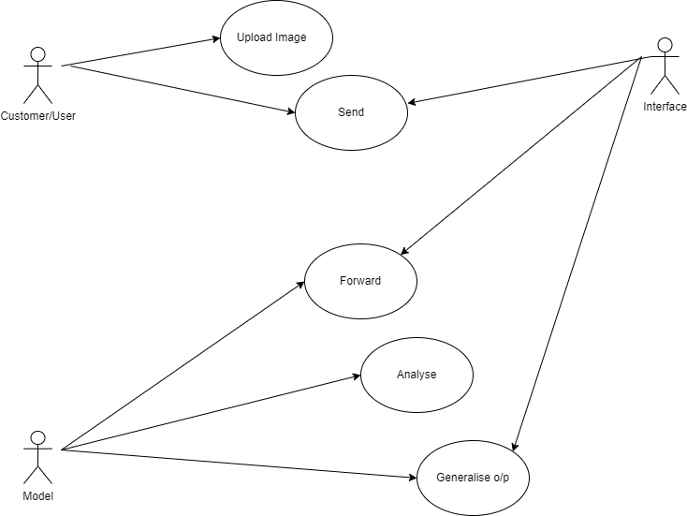

Fig 2 Use Case Diagram

**4.1.3 SEQUENCE DIAGRAM**

A sequence diagram in Unified Modelling Language (UML) is one variety of interaction diagram that suggests how methods operate with one other and in what order. It is a construct of a Message Sequence Chart. Sequence diagrams are quite often referred to as event-hint diagrams, event situations, and timing diagrams. A sequence diagram suggests, as parallel vertical traces (lifelines), special systems or objects that are residing at the same time, and, as horizontal arrows, the messages exchanged between them, within the order the place they occur.

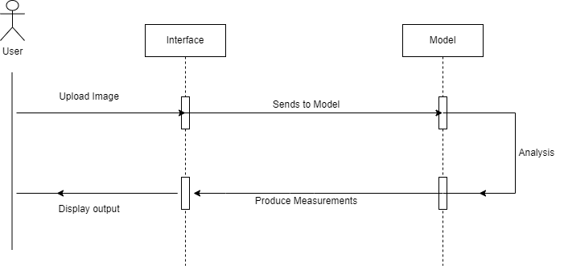

## 

Sequence Diagram

## 4.1.4 DFD Diagram:

A data flow diagram or bubble chart (DFD) is a graphical representation of the "flow" of data .through an information system, modeling its process aspects. Often they are a preliminary step used to create an overview of the system which can later be elaborated. DFDs can also be used for the visualization of data processing (structured design).

A DFD shows what kinds of information will be input to and output from the system, where the data will come from and go to, and where the data will be stored. It does not show information about the timing of processes, or information about whether processes will operate in sequence or in parallel (which is shown on a flowchart).

The primitive symbols used for constructing DFD’s are: Symbols used in DFD

A circle represents a process.

A rectangle represents external entity

A square defines a source or destination of the system data.

An arrow identifies data flow.

Double line with one end closed indicates data store

**Level 0**

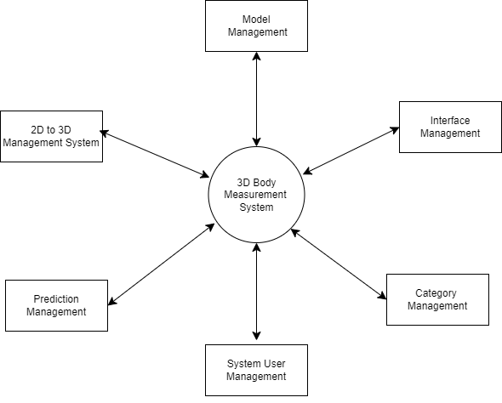

Fig 4 Level

**Level 1**

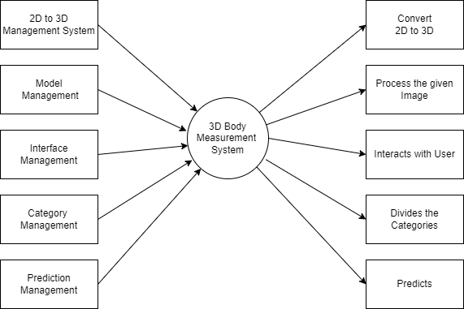

Fig 5 Level 1

**Level 2**

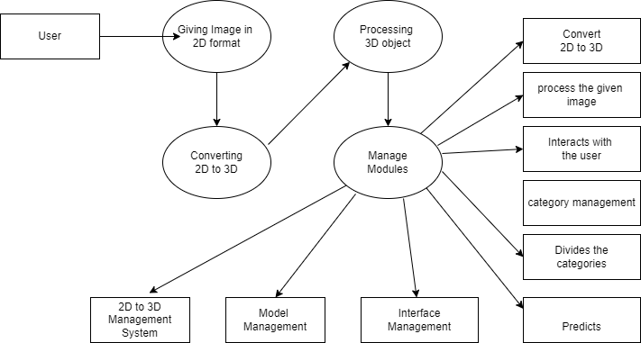

Fig 6 Level

## Chapter -5

## SYSTEM IMPLEMENTATION

**5.1 3D body measurement system**

It is done by using HTML, CSS and python with deep learning concepts , we have used the necessary components to implement this. HTML and CSS are used for interface development and python with deep learning concepts for training the model . By using NOMO-3D-400-Scans which include 194 male and 181 female subjects is used to train the model.

### **Website over look**

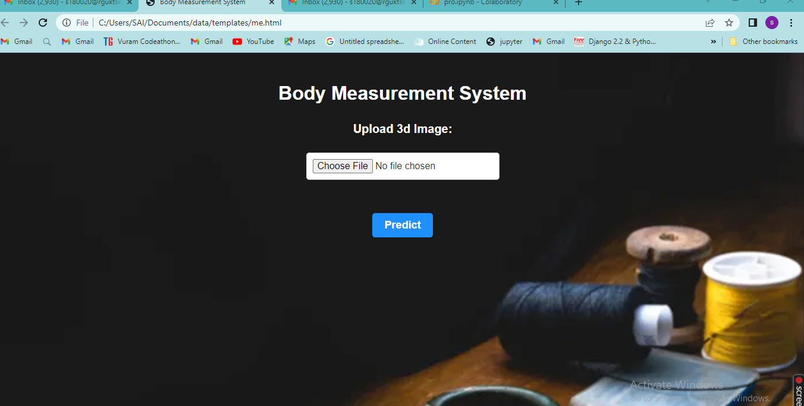

### 

### **Google colab**

### **1**

**Input**

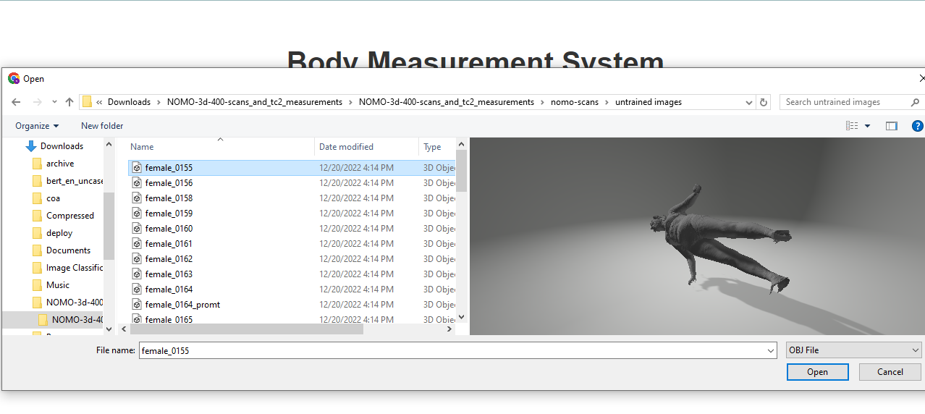

**Predicted output:**

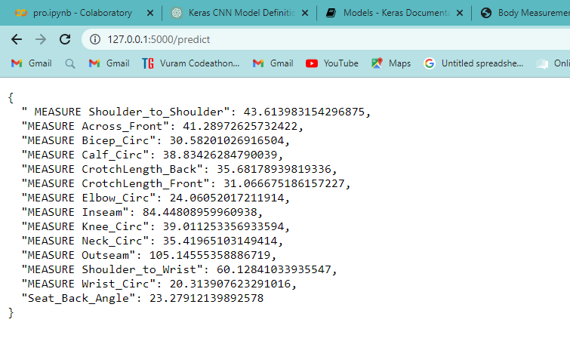

**Actual measurements:**

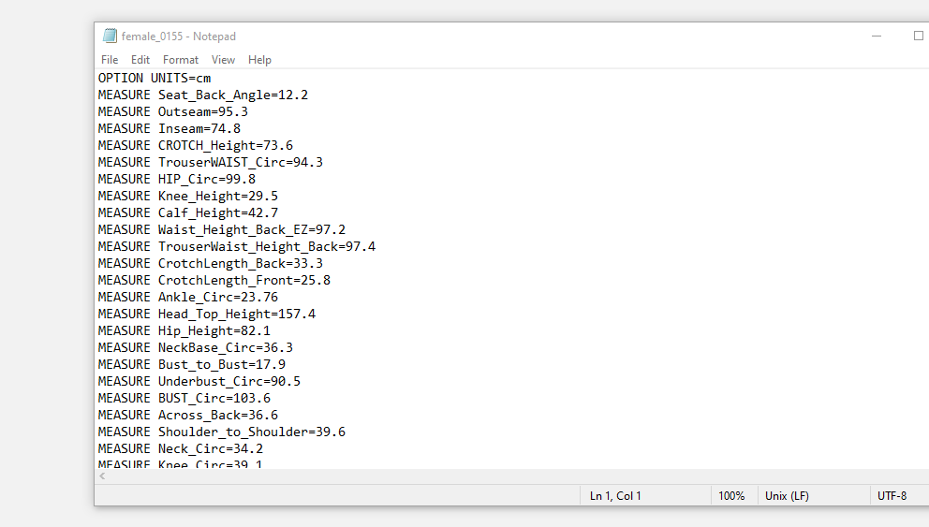

**2D to 3D :**

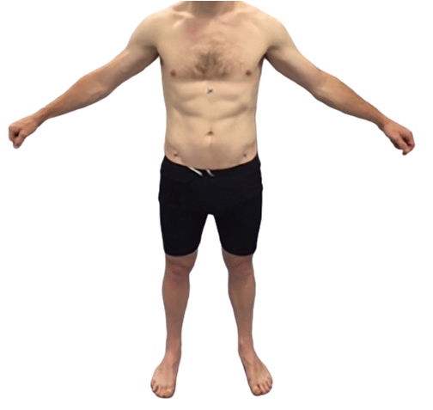

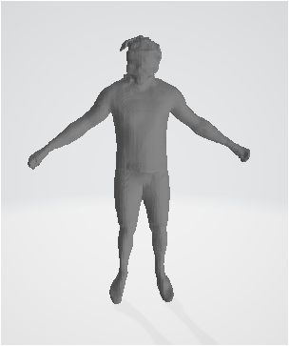

## 

## Chapter 6

## SOURCE CODE

**6.1 Training the model**

import tensorflow as tf

print("Tensorflow version " + tf.__version__)

try:

  tpu = tf.distribute.cluster_resolver.TPUClusterResolver()  # TPU detection

  print('Running on TPU ', tpu.cluster_spec().as_dict()['worker'])

except ValueError:

  raise BaseException('ERROR: Not connected to a TPU runtime; please see the previous cell in this notebook for instructions!')

tf.config.experimental_connect_to_cluster(tpu)

tf.tpu.experimental.initialize_tpu_system(tpu)

tpu_strategy = tf.distribute.experimental.TPUStrategy(tpu)

from google.colab import drive

drive.mount('/content/drive')

!pip install trimesh

# importing necessary packages

import os

import trimesh

import numpy as np

# Female Data

# Reading Female(.obj) data and converting every image into Numerical Data and Storing them in list called array

a =[]

for image in os.listdir('/content/drive/MyDrive/Nomo/female_obj'):

   if image.endswith('.obj'):

      image_path = f"/content/drive/MyDrive/Nomo/female_obj/{image}"

      a.append(image_path)

 # .obj

 duplicate = ['/content/drive/MyDrive/Nomo/female_obj/female_0061_promt.obj', '/content/drive/MyDrive/Nomo/female_obj/female_0089_promt.obj',

 '/content/drive/MyDrive/Nomo/female_obj/female_0092_promt.obj', '/content/drive/MyDrive/Nomo/female_obj/female_0137_promt.obj', '/content/drive/MyDrive/Nomo/female_obj/female_0164_promt.obj']

a = [b for b in a if b not in duplicate]

files = []

# iterate through all file

for file in os.listdir('/content/drive/MyDrive/Nomo/female_TC2Meas_txt/female_TC2Meas_txt'):

  # Check whether file is in text format or not

    file_path = f"C:/Users/SAI/Downloads/NOMO-3d-400-scans_and_tc2_measurements/NOMO-3d-400-scans_and_tc2_measurements/nomo-scans/female_TC2Meas_txt/female_TC2Meas_txt/{file}"

    files.append(file_path)

files.sort()

# Extracting Vertices

a

ve=[]

for i in range(154):

  mesh = trimesh.load(a[i])

  vertices = np.array(mesh.vertices)

  rem_vertices = 62244-vertices.shape[0]

  if rem_vertices>0:

    for v in range(rem_vertices):

      vertices = np.append(vertices,np.array([[0,0,0]]),axis=0)

  ve.append(vertices)

import pandas as pd

df = pd.read_csv('/content/drive/MyDrive/Nomo/dataset.csv')

dupl = ['C:/Users/SAI/Downloads/NOMO-3d-400-scans_and_tc2_measurements/NOMO-3d-400-scans_and_tc2_measurements/nomo-scans/female_TC2Meas_txt/female_TC2Meas_txt/.ipynb_checkpoints','C:/Users/SAI/Downloads/NOMO-3d-400-scans_and_tc2_measurements/NOMO-3d-400-scans_and_tc2_measurements/nomo-scans/female_TC2Meas_txt/female_TC2Meas_txt/female_0062_promt.txt','C:/Users/SAI/Downloads/NOMO-3d-400-scans_and_tc2_measurements/NOMO-3d-400-scans_and_tc2_measurements/nomo-scans/female_TC2Meas_txt/female_TC2Meas_txt/female_0077_promt.txt', 'C:/Users/SAI/Downloads/NOMO-3d-400-scans_and_tc2_measurements/NOMO-3d-400-scans_and_tc2_measurements/nomo-scans/female_TC2Meas_txt/female_TC2Meas_txt/female_0087_copy.txt''C:/Users/SAI/Downloads/NOMO-3d-400-scans_and_tc2_measurements/NOMO-3d-400-scans_and_tc2_measurements/nomo-scans/female_TC2Meas_txt/female_TC2Meas_txt/female_0161_promt.txt','C:/Users/SAI/Downloads/NOMO-3d-400-scans_and_tc2_measurements/NOMO-3d-400-scans_and_tc2_measurements/nomo-scans/female_TC2Meas_txt/female_TC2Meas_txt/female_0174_promt.txt','C:/Users/SAI/Downloads/NOMO-3d-400-scans_and_tc2_measurements/NOMO-3d-400-scans_and_tc2_measurements/nomo-scans/female_TC2Meas_txt/female_TC2Meas_txt/female_0161_promt.txt', 'C:/Users/SAI/Downloads/NOMO-3d-400-scans_and_tc2_measurements/NOMO-3d-400-scans_and_tc2_measurements/nomo-scans/female_TC2Meas_txt/female_TC2Meas_txt/female_0087_copy.txt'

]

# removing dupl rows from the dataframe

df = df[~df['filename'].str.contains('|'.join(dupl))]

female_data = {'MEASURE Seat_Back_Angle':df['MEASURE Seat_Back_Angle'], 'MEASURE CrotchLength_Front':df[ 'MEASURE CrotchLength_Front'], 'MEASURE CrotchLength_Back':df['MEASURE CrotchLength_Back'], 'MEASURE Knee_Circ':df['MEASURE Knee_Circ'], 'MEASURE Calf_Circ':df[ 'MEASURE Calf_Circ'], 'MEASURE Outseam':df['MEASURE Outseam'], 'MEASURE Inseam':df['MEASURE Inseam'], 'MEASURE Shoulder_to_Wrist':df['MEASURE Shoulder_to_Wrist'], 'MEASURE Bicep_Circ':df['MEASURE Bicep_Circ'], 'MEASURE Elbow_Circ':df['MEASURE Elbow_Circ'], 'MEASURE Wrist_Circ':df['MEASURE Wrist_Circ'], 'MEASURE Shoulder_to_Shoulder':df['MEASURE Shoulder_to_Shoulder'], 'MEASURE Across_Front':df['MEASURE Across_Front'], 'MEASURE Neck_Circ':df['MEASURE Neck_Circ']}

y1 = pd.DataFrame(female_data)

y11 = y1.head(154)

y1.shape

Male Data

# Reading Female(.obj) data and converting every image into Numerical Data and Storing them in list called array

b =[]

for image in os.listdir('/content/drive/MyDrive/Nomo/male_obj/male_obj'):

  if image.endswith('.obj'):

    image_path = f"/content/drive/MyDrive/Nomo/male_obj/male_obj/{image}"

    b.append(image_path)

# Extracting vertices from male data

b

# sorting the images

b.sort()

#duplicated images

n = [ '/content/drive/MyDrive/Nomo/male_obj/male_obj/male_0147_promt.obj', '/content/drive/MyDrive/Nomo/male_obj/male_obj/male_0102_promt.obj', '/content/drive/MyDrive/Nomo/male_obj/male_obj/male_0100_promt.obj',

 '/content/drive/MyDrive/Nomo/male_obj/male_obj/male_0104_promt.obj',

 '/content/drive/MyDrive/Nomo/male_obj/male_obj/male_0111_promt.obj', '/content/drive/MyDrive/Nomo/male_obj/male_obj/male_0169_promt.obj', '/content/drive/MyDrive/Nomo/male_obj/male_obj/male_0122_promt.obj',

 '/content/drive/MyDrive/Nomo/male_obj/male_obj/male_0123_promt.obj',

]

imgs = [img for img in b if img not in n]

imgs.sort()

imgs[159]

arre = []

for i in range(159):

  mesh = trimesh.load(imgs[i])

  vertices = np.array(mesh.vertices)

  remaining_rows=62244-vertices.shape[0]

  for j in range(remaining_rows):

    vertices = np.append(vertices,np.array([[0,0,0]]),axis=0)

  arre.append(vertices)

arre = np.array(arre)

ve = np.array(ve)

array = np.concatenate((arre,ve),axis=0)

arre.shape

y1.shape

len(ve)

ve.shape

x = array

male = pd.read_csv('/content/drive/MyDrive/Nomo/file.csv')

male_data = {'MEASURE Seat_Back_Angle':male['MEASURE Seat_Back_Angle'], 'MEASURE CrotchLength_Front':male[ 'MEASURE CrotchLength_Front'], 'MEASURE CrotchLength_Back':male['MEASURE CrotchLength_Back'], 'MEASURE Knee_Circ':male['MEASURE Knee_Circ'], 'MEASURE Calf_Circ':male[ 'MEASURE Calf_Circ'], 'MEASURE Outseam':male['MEASURE Outseam'], 'MEASURE Inseam':male['MEASURE Inseam'], 'MEASURE Shoulder_to_Wrist':male['MEASURE Shoulder_to_Wrist'], 'MEASURE Bicep_Circ':male['MEASURE Bicep_Circ'], 'MEASURE Elbow_Circ':male['MEASURE Elbow_Circ'], 'MEASURE Wrist_Circ':male['MEASURE Wrist_Circ'], 'MEASURE Shoulder_to_Shoulder':male['MEASURE Shoulder_to_Shoulder'], 'MEASURE Across_Front':male['MEASURE Across_Front'], 'MEASURE Neck_Circ':male['MEASURE Neck_Circ']}

y2 = pd.DataFrame(male_data)

y22 = y2.head(159)

y = pd.concat([y11,y22],axis=0)

Normalization

# Normalizing the array values

x = x/x.max()

X

Creating a Convolutional Architecture

from keras.models import Sequential

from keras.layers import Conv2D, MaxPool2D, Flatten, Dense,BatchNormalization

model = Sequential()

model.add(Conv2D(32, (3, 3),padding='same',activation='relu', input_shape=(62244,3,1)))

model.add(MaxPool2D(pool_size=(2, 2),padding='same'))

model.add(Conv2D(64, (3, 3),padding='same',activation='relu'))

model.add(Conv2D(128, (3, 3),padding='same',activation='relu'))

model.add(MaxPool2D(pool_size=(2, 2),padding='same'))

model.add(Flatten())

model.add(Dense(128, activation='relu'))

model.add(Dense(14, activation='linear'))

# Compile the model

model.compile(loss='mean_squared_error', optimizer='adam',metrics=['mean_absolute_error'])

model.fit(x,y,epochs=15,batch_size=120)

Creating Validation data to validate model

a.sort()

val_ver=[]

for i in range(154,176):

  mesh = trimesh.load(a[i])

  val_vertices = np.array(mesh.vertices)33

  remaining_rows=62244-val_vertices.shape[0]

  for j in range(remaining_rows):

    val_vertices = np.append(val_vertices,np.array([[0,0,0]]),axis=0)

  val_ver.append(val_vertices)

val_vert=[]

for i in range(160,179):

  mesh = trimesh.load(imgs[i])

  Val_vertices = np.array(mesh.vertices)

  remaining_rows=62244-Val_vertices.shape[0]

  for j in range(remaining_rows):

    Val_vertices = np.append(Val_vertices,np.array([[0,0,0]]),axis=0)

  val_vert.append(Val_vertices)

y111 = y1.tail(22)

y222 = y2.tail(19)

val_x = np.concatenate((val_ver,val_vert),axis=0)

val_x = val_x/val_x.max()

val_y = pd.concat((y111,y222),axis=0)

pred_y = model.predict(val_x)

val_x.shape

val_y.shape

Evaluating the model performance

from sklearn.metrics import mean_absolute_error

mean_absolute_error(pred_y,val_y)

# now the mean_absolute_error of the model is 4.026460503036552 which is a god sign that model is performing very well

FLASK creation

from flask import Flask, request, render_template

import trimesh

import numpy as np

import pickle

from tensorflow.keras.models import load_model

import os

from io import BytesIO

model = load_model('nemodel.h5')

app = Flask(__name__)

@app.route('/')

def ma():

return render_template("me.html")

@app.route('/predict', methods=['POST'])

def index():

if request.method == 'POST':

file = request.files['file']

data = file.read()

mesh = trimesh.load(BytesIO(data), file_type='obj')

vertices = np.array(mesh.vertices)

remaining_rows=62244-vertices.shape[0]

if remaining_rows>0:

for i in range(remaining_rows):

vertices = np.append(vertices,np.array([[0,0,0]]),axis=0)

vertices = vertices/vertices.max()

p = np.reshape(vertices, [1,62244,3,1])

predictions = model.predict(p).tolist()

results = {'Seat_Back_Angle':predictions[0],'MEASURE CrotchLength_Front':predictions[1],'MEASURE CrotchLength_Back':predictions[2],'MEASURE Knee_Circ':predictions[3],'MEASURE Calf_Circ':predictions[4],'MEASURE Outseam':predictions[5],'MEASURE Inseam':predictions[6],'MEASURE Shoulder_to_Wrist':predictions[7],'MEASURE Bicep_Circ':predictions[8],'MEASURE Elbow_Circ':predictions[9],'MEASURE Wrist_Circ':predictions[10],' MEASURE Shoulder_to_Shoulder':predictions[11],'MEASURE Across_Front':predictions[12],'MEASURE Neck_Circ':predictions[13]}

return results

if __name__ == '__main__':

app.run(debug=True)

document.getElementById(tabname).classList.add("active-tab");

**6.2 HTML CODE**

HTML

<!DOCTYPE html>

<html>

<head>

    <title>Body Measurement System</title>

    <style>

        body {

            font-family: Arial, sans-serif;

        }

        h1 {

            text-align: center;

            color: #333;

            margin-top: 50px;

        }

        form {

            display: flex;

            flex-direction: column;

            align-items: center;

            margin-top: 30px;

        }

        label {

            font-size: 20px;

            font-weight: bold;

            color: #333;

            margin-bottom: 10px;

        }

        input[type="file"] {

            font-size: 16px;

            padding: 10px;

            border-radius: 5px;

            border: 1px solid #ccc;

            margin-bottom: 20px;

            background-color: #fff;

            color: #333;

            box-shadow: 1px 1px 1px rgba(0,0,0,0.1);

        }

        button[type="submit"] {

            font-size: 18px;

            font-weight: bold;

            padding: 10px 20px;

            border-radius: 5px;

            border: none;

            background-color: #1E90FF;

            color: #fff;

            box-shadow: 2px 2px 2px rgba(0,0,0,0.2);

            cursor: pointer;

            transition: background-color 0.3s ease;

        }

        button[type="submit"]:hover {

            background-color: #008B8B;

        }

    </style>

</head>

<body>

    <p style="background-image:url('bg1.png');">

    <h1>Body Measurement System</h1>

    <form action="/predict" method="post" enctype="multipart/form-data">

        <label for="file">Upload 3d Image:</label><br>

        <input type="file" id="file" name="file" accept=".obj" required><br><br>

        <button type="submit" name="submit">Predict</button>

    </form>

</body></html>

**Chapter 7**

**SYSTEM TESTING**

##### 7.1 Introduction

The cause of testing is to detect mistakes. Making an attempt out is the technique of looking for to realize each viable fault or weakness in a piece product. It presents a method to determine the performance of add-ons, sub-assemblies, assemblies and/or a completed product. It is the method of ex excising g program with the intent of constructing certain that the application procedure meets its necessities and client expectations and does no longer fail in an unacceptable process. There are rather plenty of forms of scan. Each experiment sort addresses a special trying out requirement.

**7.2 Types of tests**

Unit testing

Unit checking out involves the design of scan circumstances that validate that the Internal application good judgment is functioning safely, and that program inputs produce legitimate outputs. All decision branches and interior code float must be validated. It's the checking out of character application items of the application. It is achieved after the completion of an person unit earlier than integration. It is a structural checking out, that relies on competencies of its construction and is invasive. Unit exams participate in common exams at component level and scan a distinct business approach, utility, and/or process configuration.

Unit assessments be certain that every specified course of a industry method performs appropriately to the documented requisites and involves clearly outlined inputs and anticipated results.

Integration testing

Integration Testing are designed to scan built-in program accessories to determine within the occasion that they evidently run as one software. Trying out is occasion driven and is more concerned with the fundamental final result of screens or fields. Integration assessments reveal that despite the fact that the accessories had been for my part pleasure, as proven through effectively unit checking out, the combo of accessories is correct and regular. Integration checking out is chiefly aimed at exposing the issues that come up from the performance of different components.

### Functional testing

Functional Testing checks provide systematic demonstrations that capabilities established are to be had as particular by means of the business and technical specifications, method documentation, and consumer manuals. Functional testing is working on below mentioned data:

Legitimate input : identified lessons of legitimate input ought to be accredited. Invalid enter : recognized lessons of unacceptable effort must be rejected.

Capabilities : recognized features ought to be exercised.

Output : recognized courses of software outputs have got to be

exercised. Systems/Procedures : performance of the system here was invoked Individual and team work of useful checks is fascinated by specifications, key capabilities, or special scan instances. Moreover, systematic insurance plan concerning establish business method flows; data fields, predefined processes, and successive strategies have to be regarded for trying out. Before useful trying out is whole, extra checks are recognized and the strong price of present checks be strong- minded.

### 

### System testing

scheme difficult ensure so as to the whole included agenda process meets principles. It exams a pattern to make sure identified and predictable outcome. An illustration of procedure testing is the configuration oriented approach integration scan. System testing is based on approach descriptions and flows, emphasizing pre-driven system links and integration aspects.

### White Box Testing

This testing is a trying out wherein where the application tester has competencies of the interior workings, constitution and software language, or at least its cause. It's rationale. It's used to test areas that can't be reached from a black box stage.

### Black Box Testing

This is testing the software with none advantage of the inside workings, establishment or words of the unit life form veteran.

# 

# 

# 7.3 Levels of testing

### Unit testing strategy

Unit checking out is most commonly performed as a part of a mixed code and unit experiment part of the software lifecycle, though it be not exceptional for coding and unit checking out to be performed as two targeted phases.

Test strategy and approach:

Field testing out can be carried out manually and sensible assessments shall be written in element.

Test objectives

Each field must be work correctly.

Each page must be activated through the specified link.

Features to be tested Verify that the entries are of the correct format No duplicate entries should be allowed

### Integration testing strategy

Software integration testing is the incremental integration checking out of two otherwise further included software gears on top of a solo stage to fabricate failure induced with the aid of interface defects. The project of the mixing scan is to check that components or program applications,

e.g. Components in a program approach or œ one step up œ software purposes at the company degree œ interact without error.

Test Results:

All of the scan circumstances recounted above passed efficiently. No defects encountered.

### Acceptance Testing

User Acceptance testing trying out is a crucial section of any mission and requires enormous participation by the tip user. It additionally ensures that the procedure meets the functional specifications.

Test Results:

The entire test cases recounted above passed effectually. No defects Encountered

**CONCLUSION:**

In this project , 3d body measurement system using deep learning with python provides an efficient and accurate solution for obtaining body measurements without requiring physical effort or lengthy measurements taken by a tailor.

This system can significantly reduce the time and effort required for obtaining accurate body measurements and can be used to find the best garment fit for online shopping , reducing the return rate of products. Overall , this project demonstrates the potential of deep learning and computer vision techniques in developing innovative solutions for practical problems.

# FUTURE ENHANCEMENT

Further we can include brand size recommendation system which reduces the return policy in e-commerce applications.

**REFERENCES**

* N.Mahmood , N.Ghorbani , N.F.Troje , G.Pons-Moll , and M.Black , ‘ ‘AMASS:Archive of motion capture as surface shapes , ’ ’. IEEE/CVF Int.Conf.Comput.Wis.(ICCV) , Oct. 2019, pp. 5442-5451.
* S. Prokudin, Christoph Lassner, and J. Romero. Efﬁcient learning on point clouds with basis point sets. 2019 IEEE/CVF International Conference on Computer Vision (ICCV), pages 4331–4340, 2019.
* M. Ribo and M. Brandner. State of the art on vision-based structured light systems for 3d measurements. In International Workshop on Robotic Sensors: Robotic and Sensor Environments, 2005., pages 2–6, 2005.
* K. Sun, Bin Xiao, Dong Liu, and Jingdong Wang. Deep high-resolution representation learning for human pose estimation. 2019 IEEE/CVF Conference on Computer Vision and Pattern Recognition (CVPR), pages 5686–5696, 2019.